**Food Insecurity in North Carolina:  
Analyzing Demographic Impacts with Clustering**

Mahmoud Alhousseiny, Tacoma Jones, Mason Keziah, Gray Lumsden  
University of North Carolina at Charlotte - School of Data Science  
DTSC 4301/4302: Data Science for Social Good  
Mirsad Hadžikadić, Ph.D. & Ted Carmichael, Ph.D.  
May 2nd, 2024

**Abstract**

In the United States, increases in factors such as cost of living, price of housing, unemployment, and low-wage jobs have contributed to a large portion of the population experiencing Food Insecurity. When individuals face the challenge of obtaining adequate food due to economic constraints or geographical limitations, they are at risk of poor nutritional health. This condition is officially termed by the United States Department of Agriculture (USDA) as “Food Insecurity” (hereby referred to as FI) and is defined as “the limited or uncertain access to adequate food .” FI affects people from various demographics, highlighting widespread challenges. While broad data concerning FI on a national scale exists, studies focused locally in North Carolina remain sparse. This study employs socio-economic, demographic, and spatial data acquired from the Food Access Research Atlas, Map the Meal Gap, and Census data to construct a clustering model that identifies patterns associated with FI in North Carolina. We utilize a k-means clustering model paired with PCA in order to reduce dimensionality while creating a total of four cluster profiles. Following the clustering model, a k-nearest neighbors regression model is used to validate the results further. Each profile represents the differing needs of counties for every county. Key findings indicate that rural and suburban counties have the highest FI rates and the greatest distances to a supermarket. Cluster 2 has among the worst socio-economic measures, such as the highest poverty rate and lowest education attainment rates. Cluster 1 has the furthest distances to supermarkets and the second-highest food insecurity rates.

**Food Insecurity in North Carolina: Analyzing Demographic Impacts with Clustering**

In 2021, 10.2% of Americans faced food insecurity, according to the U.S. Department of Agriculture, Economic Research Service (2023). Within the same year, 11.8% of the North Carolina population experienced food insecurity (Smith, 2024). Every state and county in the U.S. experiences food insecurity to varying degrees. North Carolina is well above the national average of 10.2%, which positions North Carolina as an exemplary case study to examine influential factors of FI at a county level. When individuals face the challenge of obtaining adequate food due to economic constraints or geographical limitations, they are at risk of poor nutritional health. This condition is officially termed by the United States Department of Agriculture (USDA) as “Food Insecurity” (hereby referred to as FI) and is defined as “the limited or uncertain access to adequate food.” FI has been shown to disproportionately impact individuals depending on their age, race, ethnicity, or sex. (MTMG, 2023).   
 Despite widespread studies of FI contributors and consequences nationally, localized research is sparse and thus highlights the need for more granular analysis. Analyzing FI at the county scale is vital due to inter-county and demographic variations, acting as a bridge between household or local-level FI interventions and global-scale considerations. This detailed approach ensures more accurate insights, facilitating precise interventions like policy formulation, resource distribution, and the development of effective local strategies to combat FI.  
 This study employs advanced machine learning techniques to delve into the complexities of food insecurity in North Carolina. It utilizes socio-economic data from the Food Access Research Atlas, Map the Meal Gap, and the U.S. Census to explore underlying factors such as poverty rates, median income, educational attainment, and unemployment rates. Additionally it incorporates geospatial indicators, such as supermarket proximity, to gauge their impact on food insecurity. The use of machine learning techniques, particularly clustering, allows for the identification of patterns within the different clusters. This approach aims to uncover critical predictors of food insecurity, with a specific focus on how it varies across diverse demographics and counties within the state.  
 This study further considers the significant influence of socio-economic variables on FI rates among different racial and ethnic groups, noting the potential for higher rates in specific communities. It examines the relationship between supermarket accessibility and FI, hypothesizing that greater distances to food sources could exacerbate insecurity levels. This approach is designed to inform targeted interventions and address the root causes and demographic impacts of FI. The ultimate goal is to contribute to the body of knowledge on FI. These contributions should facilitate strategies that ensure food access and improve quality of life across North Carolina. This study connects to broader social issues like health disparities, economic inequality, and the pursuit of equal opportunity.   
 The study will first differentiate between interconnected problem spaces by distinguishing FI from other concepts. This will lead to further discussion on FI and allow this study to assess the current space and plan for further analysis. This research will enable data analysis and the creation of cluster models for observational purposes. Considering the importance of race and proximity to supermarkets in predicting susceptibility to food insecurity (FI), we hypothesize that analyzing counties with irregular FI rates can reveal effective or harmful practices. Counties with lower FI rates may have robust food assistance programs and accessible food markets, whereas those with higher rates might lack these resources.

**Literature Review - Background**

The term 'Food Insecurity' is relatively unique in concept, though it's commonly mistaken with other similar terminologies, like hunger and nutrition insecurity. The problem space surrounding FI is focused on the limited or uncertain access to adequate food. In contrast, nutrition security is focused on the quality and nutritional values of a diet (U.S. Department of Agriculture, 2023). Distinguishing between these terms provides context to the focus of the research by acknowledging the elimination of FI as the gateway to alleviating other problem spaces, like nutritional security, food sovereignty, food inequality, etc. To ensure that households have access to nutritional food, it is necessary first to ensure that they have access to enough food. By breaking down the problem space – The health of every individual within our society – into more singular components, such as food access or food quality, we have the opportunity to isolate overwhelming problem spaces into ones that are both interpretable and actionable.  
 There are also more ambiguous terms that coincide within the problem space of FI, such as 'hunger' or 'malnutrition.' The USDA makes a clear distinction between FI and hunger, emphasizing hunger as a consequence of FI. Hunger is an individual and physiological condition, while FI is a socio-economic condition on the household level rather than on the individual level. The USDA notes that hunger "...should refer to a potential consequence of food insecurity that, because of prolonged, involuntary lack of food, results in discomfort, illness, weakness, or pain that goes beyond the usual uneasy sensation" (USDA). Given that hunger is an obvious hindrance to an individual's health, it is one of the main consequences of FI that studies, such as this one, aim to alleviate in the context of social good. Observing FI and its underlying factors tackles the problem of hunger at a structural level rather than individual, and therefore contains the potential for a more meaningful contribution.  
 In a study by Bowen, Elliot, and Hardison-Moody, it was found that many socio-economic factors contribute to racial disparities in food insecurity (FI) in the United States, with racism being a fundamental and significant cause. They emphasize this sentiment in stating, "...we argue that to address food insecurity truly, it is necessary to adopt a wider perspective, looking at how experiences of food insecurity are not only tied to the allocation of material resources but rooted in racism" (Bowen et al., 2021). Relationships between variables such as race or ethnicity with FI have been shown to correlate with one another; this trend is hypothesized to expand toward other variables related to social identities. Myers and Painter establish that when socio-economic status is standardized, the divide in FI between each race is more significant than between each ethnicity. The findings of this research emphasize that "black [people] and Latinos – regardless of nativity status – are significantly more food insecure than both foreign- and native-born Whites" (Myers & Painter, 2017). In this way, existing research can be used to hypothesize the relative impact of socio-economic variables regarding FI.  
 Regarding the spatial characteristics of FI, a peer-reviewed study by Allard and Ruggles (2017) analyzes the impact of supermarket accessibility on food insecurity using data from the National Household Food Acquisition and Purchase Survey (FoodAPS). This research delves into the concept of "food deserts," geographic areas lacking sufficient access to affordable, nutritious, and easily accessible food, and how they contribute to higher rates of food insecurity (Allard & Ruggles, 2017). By examining the geographical distribution of food retailers and corresponding household food purchases and pricing, the study provides significant insights into the socio-economic factors affecting food accessibility. The findings of Allard and Ruggles highlight a link between the availability of local supermarkets and food security among low-income populations (Allard & Ruggles, 2017). Their research showcases the need for targeted policy interventions that can improve access to nutritious and affordable food in underserved communities. By identifying the specific areas where access is limited, policymakers and community planners can better focus their efforts to address these gaps and potentially reduce food insecurity.  
 Another socio-economic variable worth considering is educational attainment. In a global capitalist structure, higher levels of education indicate higher quality and quantity of skills in the workforce that translate to better job opportunities and more financial stability. Thus, it is likely that a higher household education level will correlate with lower susceptibility to being food insecure. This is supported by a study published in Food Security that measured the effect of education on FI in urban Kenyan settlements, but extra considerations are needed. Researchers concluded that a large portion of the relationship between food insecurity and educational attainment could be explained by proxy of wealth. They also considered the reverse causality of the relationship, where higher education can help prevent food insecurity, and a lack of food insecurity also promotes higher education. In consideration of these limitations, "education was expected to exert its effect through a wealth index, which was a proxy measure for household income. Although the household wealth index mediated the effect of household education attainment, it did not eliminate it entirely" (Mutisya et al., 2016). These findings suggest that despite income explaining a lot of variability between educational attainment and food insecurity, the relationship has potential for further exploration and new findings.  
**Methodology** This study considers several variables when analyzing FI in North Carolina. The socio-economic variables provided by the census include the number of SNAP (Supplemental Nutrition Assistance Program) recipients, cost per meal, poverty, median household income, and unemployment rates. We expect these variables to act as FI indicators, offering insights into how economic conditions shape its prevalence. Additionally, the FARA database is utilized to measure geospatial indicators, such as proximity to supermarkets. The USDA's "Food Access Research Atlas” (FARA) is the second data source and showcases spatial measures for supermarkets' proximity. This variable can vary in distance, from 0.5 to 15 miles from a supermarket. Access to supermarkets is important within the context of food accessibility for the demographics of North Carolina and is often an indicator of socio-economic status (Tanoh & Hashemi-Beni, 2023). There are different distance values for urban areas when compared to rural areas. For example, FARA provides features that are defined as the population count beyond one mile for urban areas and 10 miles for rural areas. The distinction accounts for urban areas, with higher walkability and less car access, that require shorter distances to grocery stores for easy commuting compared to more spread-out rural areas, which typically rely on cars.  
 The census captures demographic data such as rage, age, and population. Different demographics may experience varying levels of FI due to factors such as age, race, and family composition (Sigalo et al., 2022). Family composition indicates whether the family is single, married, or divorced. Educational attainment is another critical census variable, showcasing the rates of the highest level of education completed by different groups and ages. Education often correlates with economic opportunities and awareness of nutritional needs, impacting FI levels (Buys & Rennekamp, 2020). The greater one's educational attainment level is, the more opportunities available to them and a greater chance of acquiring a higher socio-economic status.  
 The outcome variable is the overall food insecurity rate provided by Feeding America's "Map the Meal Gap". Feeding America's "Map the Meal Gap" has comprehensive data, with over 3100 rows and 18 features regarding various indicators concerning food insecurity for different demographics across all North Carolina counties. The data for Map the Meal Gap is collected using a combination of sources, including the Current Population Survey (CPS) and the American Community Survey (ACS) (Feeding America, 2017). CPS provides data on a national scale, which is analyzed to understand the relationships between food insecurity and its determinants at the state level. ACS provides detailed demographic data at the county and congressional district levels, which helps in refining the estimates to more local contexts (Feeding America, 2017). To determine if a person is food insecure, Map the Meal Gap uses a statistical model that incorporates socio-economic variables from the CPS and ACS to create the FI rate (Feeding America, 2017). The model then calculates the probability of a household not having enough money or resources to buy food for every member over a full year. These estimates are adjusted for local factors like food prices, which can vary significantly from one area to another, thus providing a nuanced view of food insecurity via the FI rates (Feeding America, 2017). Map the Meal Gap serves to enhance the understanding of FI from a demographic and socio-economic perspective and offers the target variable of the overall food insecurity rate.  
 Variables from the census, such as educational attainment, median income, unemployment rate, poverty rate, price per meal, number of SNAP recipients, and population values, are measured in value counts relative to the total population of a county. These variables are the social and economic factors that characterize the standing of an individual or group within a society (Tanoh & Hashemi-Beni, 2023). These indicators are proven socio-economic status measures that directly impact health outcomes and food access (Braveman et al., 2010).  
 Supermarket proximity provided by FARA is the ease of access to supermarkets or grocery stores that offer a range of nutritious food options. Grocery stores in the Food Access Research Atlas are measured by the distance in miles from the centroid of a population area to the nearest supermarket, using GIS data by county provided by the Atlas. GIS measures of supermarket proximity have been validated in studies linking physical access to dietary habits (Walker et al., 2010). FI rates will be measured as the percentage of the population in a given county experiencing food insecurity based on criteria set by Feeding America's "Map the Meal Gap." FI rates by "Map the Meal Gap" are supported by extensive research; these rates are considered valid measures of community food access challenges (Coleman-Jensen et al., 2020).  
**Analysis** Before conducting the analysis, we begin by merging seven different datasets, followed by a comprehensive data cleanse where we address missing values, outliers, and inconsistencies. Due to a large portion of rural counties lacking data within the newly merged dataset and some portions being limited to 2019, the choice was made to drop these observations. This decision results from the lack of available data that features all 100 counties in North Carolina. This exclusion reduces the initial number of observations (counties) to 41, with 155 features aggregated from the varying datasets accumulated. Despite the reduction in the dataset, the large number of features compared to the number of items results in high dimensionality. Given this, as well as the lack of a predictable target variable and the context of the study, using a predictive model is less practical.  
 After establishing a basis of variables, we proceed with a clustering model. We utilize Principle Component Analysis (PCA) to reduce the dimensionality in the data, which benefits the model by improving the overall accuracy of the produced clusters. This analysis aims to produce meaningful clusters and draw insight into relationships discovered through the modeling process.

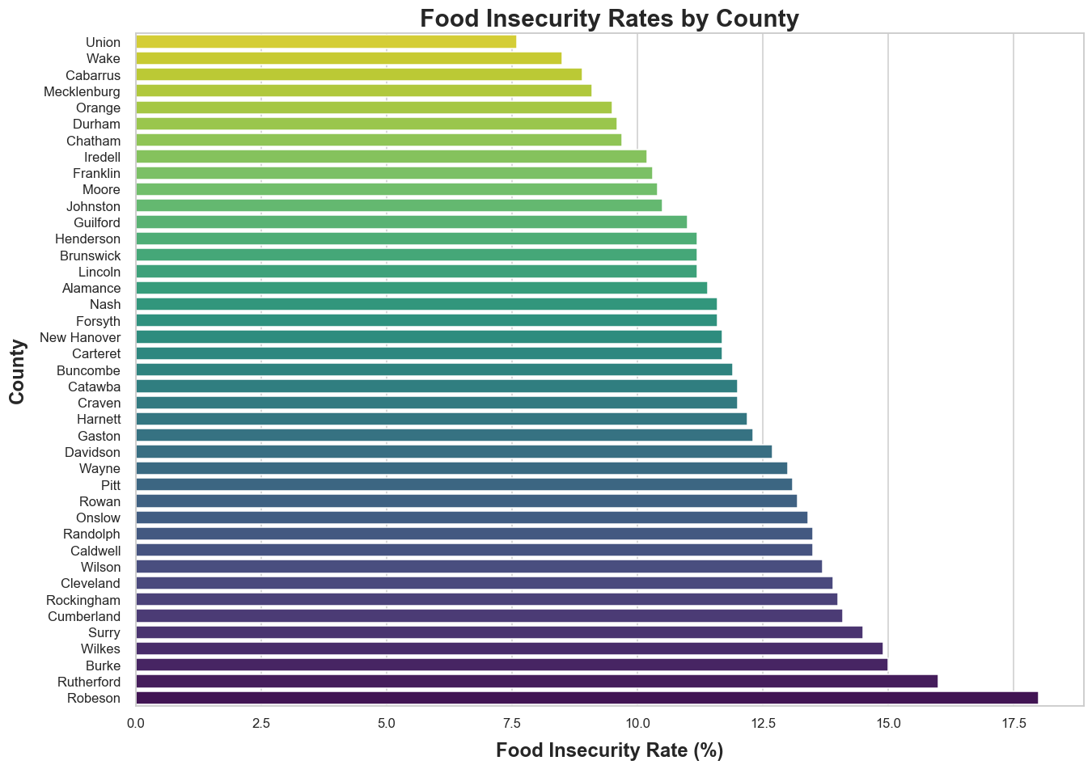***Figure 1.1.*** *Food insecurity rates across each North Carolina county*

The first level of analysis occurs by observing the FI rates of the 41 North Carolina counties. Figure 1.1 provides a visual representation of this, depicting a fairly linear increase in FI rates across each county, with a few discrepancies. The two most obvious items featured in this graph are coincidentally the minimum and maximum rates of FI among all counties, those being Union county and Robeson county. Aside from these two major examples, Rutherford county also deviates from the gradual increase present within this visual. Other items appear to trend gradually, which can potentially be explained later during variable analysis alongside the reasonings for the three heavy outliers.

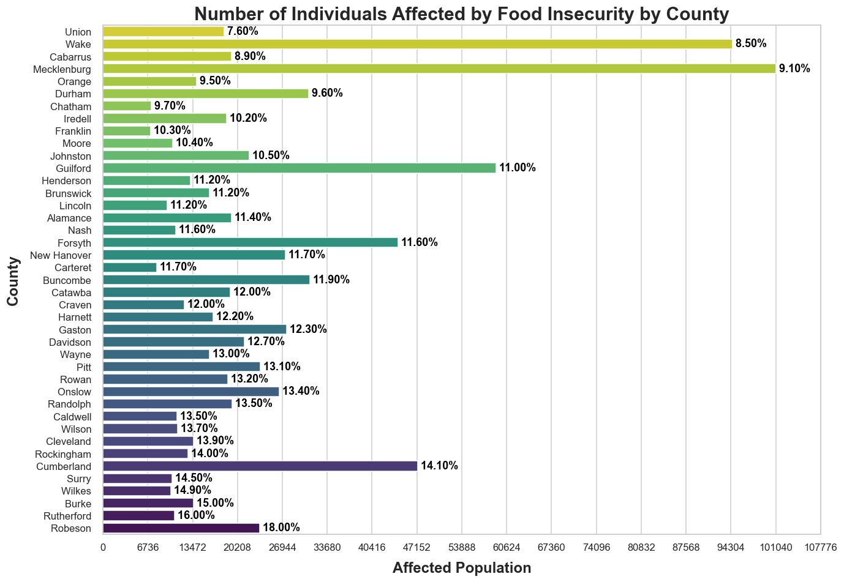***Figure 1.2.*** *The number of individuals affected by food insecurity across counties. Sorted by FI rate –with the  
FI rate denoted by the black text to the right of each bar– to contrast rates with population sizes.*

Figure 1.2 is arranged by FI rates, similar to Figure 1.1, to highlight the importance of considering population density in the context of FI. For example, Robeson County has the highest FI rate out of all North Carolina counties. This equates to around twenty-three thousand individuals, which is only half of those affected in Cumberland County, and has an FI rating four points less than Robeson County. This visual emphasizes the clear importance of understanding what factors are provoking extremely high FI rates that disproportionately affect counties like Robeson County. However, the number of food-insecure individuals in counties like Wake and Mecklenburg should not be ignored. Despite having half the FI rate of Robeson County, Mecklenburg experiences five times as many cases of FI than Robeson. The amount of affected individuals warrants further exploration into counties with dense populations. Aside from the mentioned counties, other counties in Figure 1.2 follow similar trends and should be similarly explored. Ultimately, this visualization emphasizes the need to consider counties case-by-case and consider the context of the levels of FI present within each.

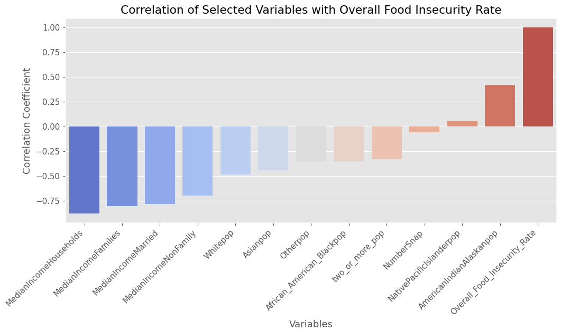

***Figure 1.3.*** *The positive or negative correlation for demographics related to the overall food*

*insecurity rate. Helps to identify positive and negative correlations.*

In Figure 1.3, the median income is represented by the four variables for households, families, married, and nonfamily households and show a negative correlation with food insecurity, suggesting that higher income is associated with lower food insecurity rates. The negative correlation ranges from moderate to strong, with coefficients from -0.5 to -0.75. For the variable denoting the White population, it showcases a negative correlation of -0.49 that suggests that counties with a higher percentage of White populations tend to have slightly lower food insecurity rates. Some other race-related variables including Asian, Other, African American, two or more races population, and Native Pacific Islander as well as the number of persons who receive snap benefits all showcase weak correlations. The only variable that showcases weak to moderate positive correlation is the one for American Indian and Alaskan Native populations. The final variable is the food insecurity rate, which is the reference variable and thus has a positive coefficient of 1.00. The demographic correlations are particularly important because some groups, like Native American populations, can be a primary indicator for high FI rates. 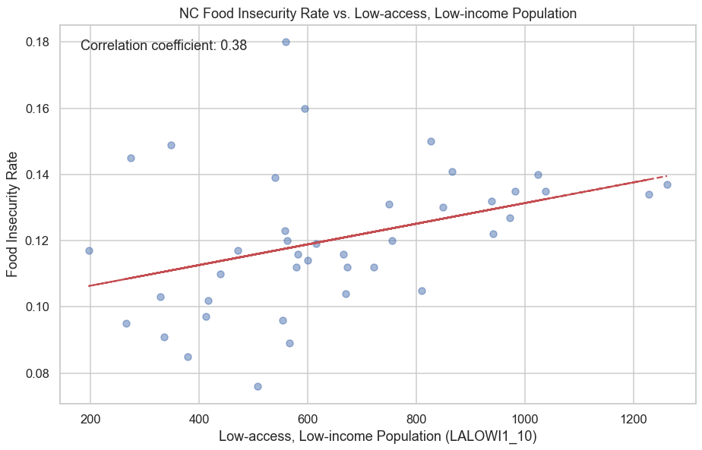

***Figure 1.4.*** *The relationship between food insecurity rates and the low-access, low-income population and their proximity to supermarkets. (LALOWI1_10) is a variable from FARA that shows a 1 mile radius from a supermarket for urban areas and 10 mile radius for rural areas.*

Figure 1.4 shows a correlation coefficient of 0.38, suggesting that there is a moderate positive relationship between the low-access, low-income population and the food insecurity rates in North Carolina counties. This implies that areas where a larger portion of the population lives beyond the defined distance from a supermarket tend to experience higher food insecurity rates. The correlation is moderate suggesting that food insecurity is influenced by multiple factors. The other variables in the dataset need to be considered before making any decisions.

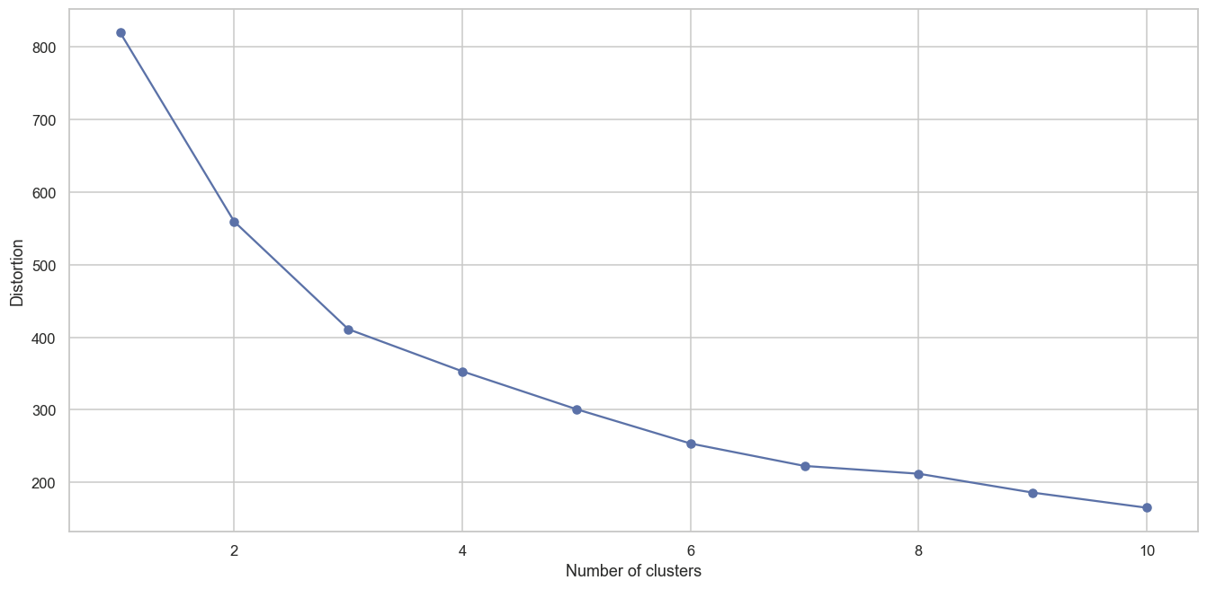***Figure 1.5.*** *Elbow plot – used to determine the optimal number of clusters for k-means clustering*

Before k-means clustering, it is necessary to determine how many clusters should be used within the model. The elbow method is utilized to determine the optimal number of clusters for the model. While this type of analysis is heuristic in nature, it is appropriate given the lower dimensionality and smaller pool of items. In Figure 1.5, the distortion begins to plateau around four clusters. Therefore, K = 4 is chosen for the model. Therefore, four cluster profiles are created that feature different county characteristics. In order to validate these results, an additional model is created using the K-Nearest Neighbors Regressor. Models such as xgboost, support vector regressor, random forest regressor, decision tree regressor, and linear regression could not explain the dataset's variability compared to k-nearest neighbors. The model resulted in a mean squared error of 0.01, root mean squared error of 0.02, mean absolute error of 0.02, and r² value of 0.61. Overall, the model shows good accuracy per the error metrics but has moderate predictive power according to the r² value. This discrepancy might suggest that while the model is very precise in a narrow range of predictions, it may not generalize as effectively across more diverse or unseen data. This is due to the high dimensionality of the dataset and the fact that it does not represent all 100 counties in North Carolina.

**Results**

Following operationalization and data exploration, results are evaluated from the four clusters created. Before analyzing the results, it is important to understand how the variables are reflected across PCA1 and PCA2. Principle component 1 (PCA1) primarily captures variance associated with racial diversity and median income levels, indicating a strong relationship with socio-economic and demographic profiles. High loadings in PCA1 from variables that represent the White population, Asian population, and income metrics suggest that it represents regions with higher income levels and greater racial diversity. Principal Component 2 (PCA2) contrasts demographic factors such as the Native Pacific Islander population with economic indicators like food insecurity rates and median income for married couples. High positive values in PCA2 correspond to areas that have low access to supermarkets and specific demographic traits, while negative values point to economic challenges such as higher food insecurity rates. Figure 2 shows the distribution of the four k-means clusters below, with PCA2 and PCA1 representing the y and x-axis, respectively.

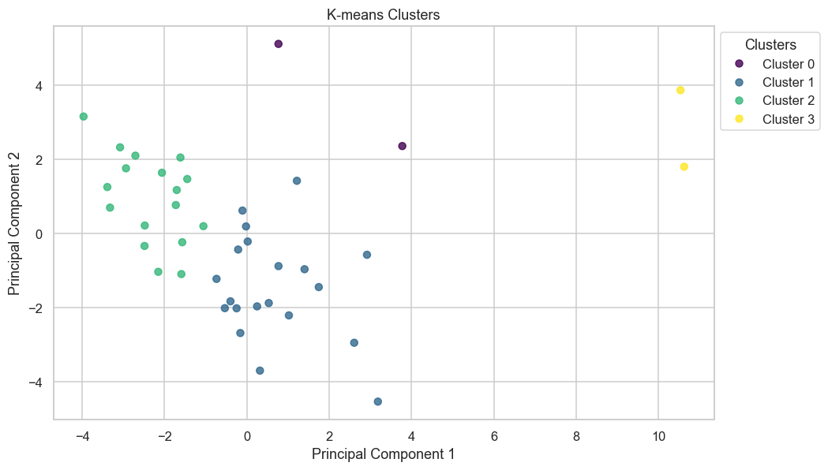

***Figure 2.*** *K-means clustering results with PCA.*

Four distinct clusters categorize counties based on population distribution, supermarket access, and socio-economic factors. Cluster 0, consisting of Guilford and Cumberland counties, represents areas with moderate population sizes across all demographics. Despite better access to supermarkets, this cluster experiences a high FI rate of 12.5%, the second highest among the clusters. It is characterized by moderate median income levels and a moderate number of SNAP recipients, indicating a relatively balanced socio-economic status with moderate concerns of FI.  
 Cluster 1 includes counties with smaller population sizes, such as Union, Cabarrus, Orange, Durham, and Chatham, featuring the lowest FI rate of 7.6% in Union County. This cluster, which has the most counties, features the lowest mean unemployment and a lower number of SNAP recipients, suggesting a stable environment with potentially less need for food assistance. Cluster 1 counties can be categorized as primarily suburban, with some being rural. In contrast, cluster 2 includes counties like Robeson, facing the highest FI rate at 18% due to significant challenges in accessing food retailers. This cluster highlights benefits that can be derived from improved public transportation and food market development to address these accessibility issues.  
 Cluster 3 contrasts sharply with cluster 1 by including densely populated urban centers like Raleigh and Charlotte in Wake and Mecklenburg counties. This cluster has the highest median income levels and unexpectedly the lowest overall FI rate at 8%, possibly reflecting the effectiveness of food assistance programs and employment initiatives. However, the limited data for this cluster warrants cautious interpretation since only two counties make up the entirety of cluster 3.  
 Demographically, the clusters display diverse racial compositions. Cluster 0 shows a balanced mix of races, cluster 1 is predominantly White, and cluster 2 includes a diverse population with a higher proportion of American Indians and Native Pacific Islanders. Cluster 3 features a significant African American population alongside a White majority. Economically, cluster 0 is the most challenged, while cluster 3 is the most affluent. Clusters 1 and 2 hold intermediate positions economically, with cluster 1 having a higher median income for households and families compared to cluster 2.  
 The socio-economic variables vary significantly across the clusters. Cluster 3 boasts the highest median income and educational attainment rate at 90%, reflecting its high socio-economic status. Despite having the second-highest educational attainment levels, cluster 0 struggles with the highest FI rate, emphasizing the complex interplay of education and economic stability in addressing FI.

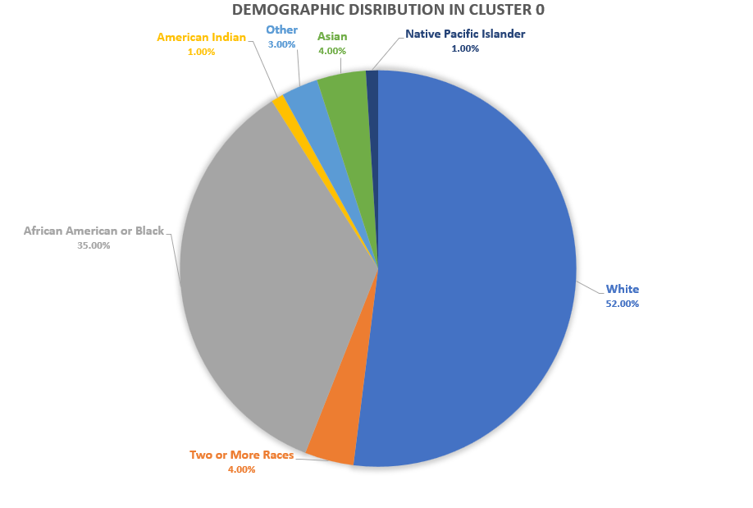

***Figure 2.1:*** *Cluster 0’s demographic profile*

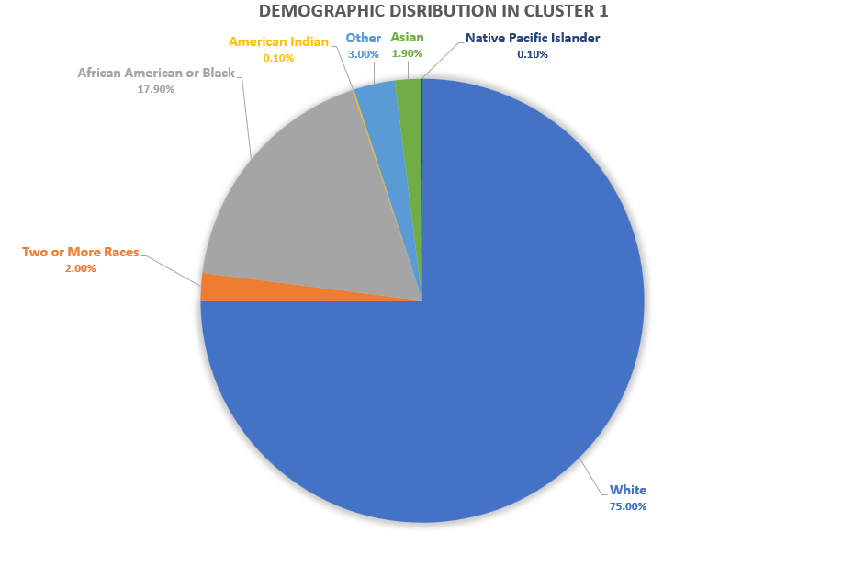

***Figure 2.2:*** *Cluster 1’s demographic profile*

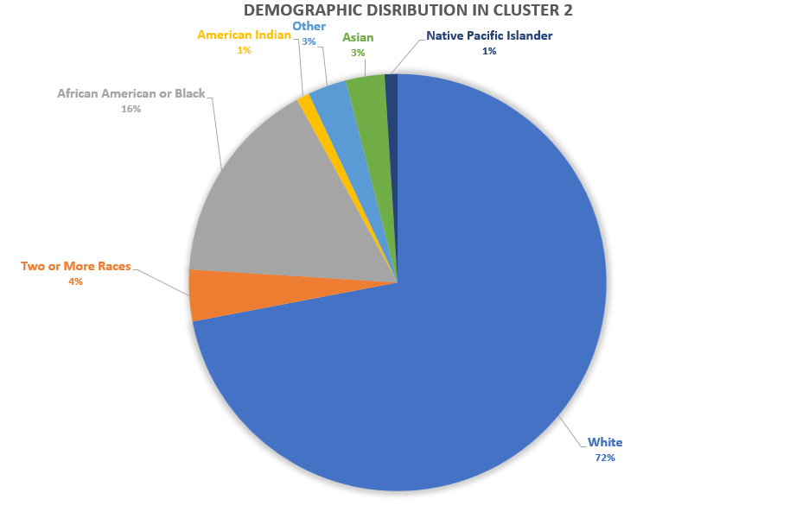

***Figure 2.3:*** *Cluster 2’s demographic profile*

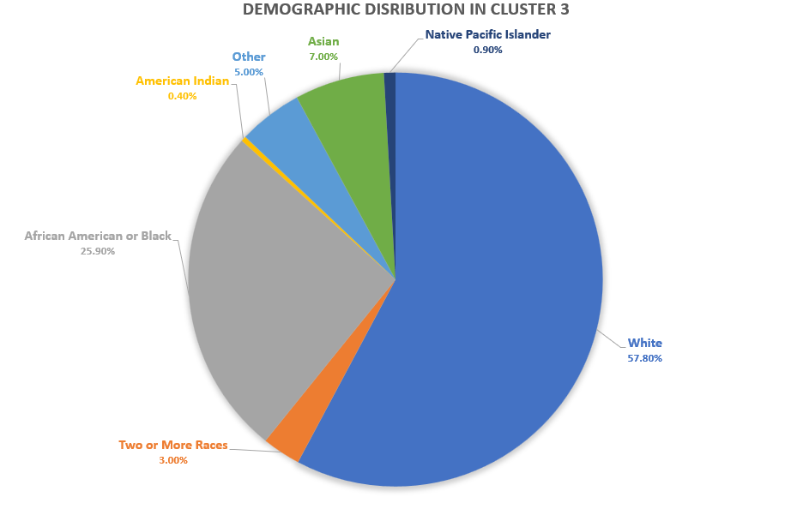

***Figure 2.4:*** *Cluster 3’s demographic profile*

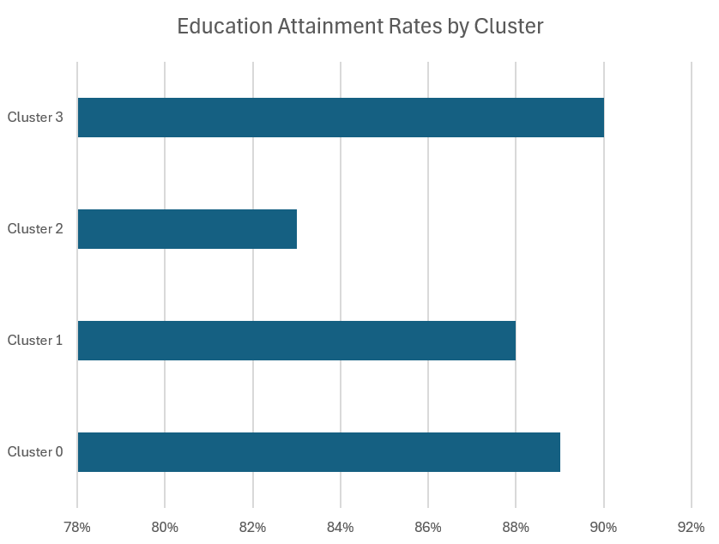

***Figure 2.5:*** *Educational Attainment Rate (%) by Cluster*

With the differences between cluster compositions having been identified, targeted interventions can be designed by analyzing the outliers within each cluster. We can shift focus to counties most affected by FI, examining their access to food markets, population distribution, food assistance programs, and economic conditions. Due to the small number of entries in clusters 0 and 3, the analysis will primarily consider outliers from clusters 1 and 2. While this limits observations in clusters 0 and 3, their smaller sample sizes and lower FI rates make a detailed study of clusters 1 and 2 more critical. This approach allows us to pinpoint areas of concern in FI and explore how effective strategies from counties with lower rates could be implemented elsewhere.

Below is Figure 3, detailing some outliers for cluster 1.

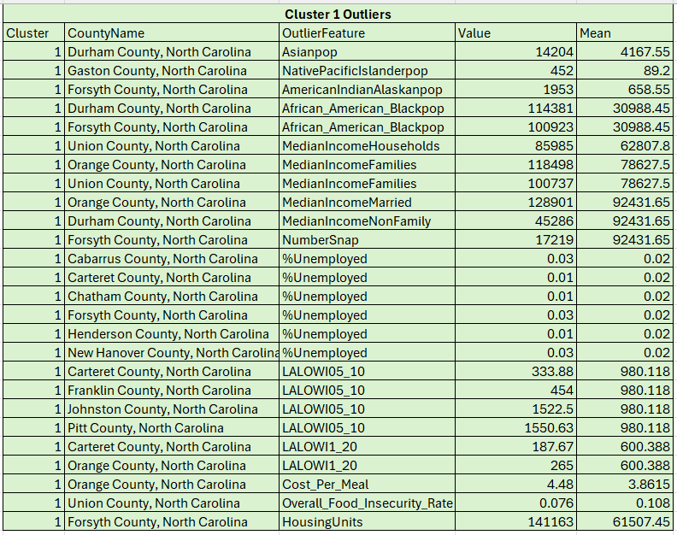

***Figure 3:*** *Cluster 1 Outliers*

As discussed previously, cluster 1 holds the lowest average rate for overall food insecurity and the outlier features from this cluster can be used to determine why that is. Figure 4 shows values for some of the features in Union county, notable for having the lowest FI rate of any county in the state at 7.6%. Union county also has additional outliers in its unusually high median income for both families and households at over $20,000 higher per year than the average county in cluster 1. Additionally, Union County has lower metrics on LALOWI05_10 and LALOWI1_20, suggesting that people in the county have to travel fewer distances to reach their newest supermarket. Surprisingly, Union county residents experience an average unemployment rate and average cost per meal within the cluster, implying a lack of impact of these variables on overall FI rates in this case at least.

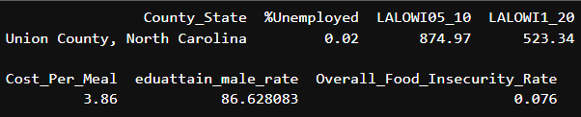

***Figure 3.1:*** *Union County features*

The data suggests through Union County's outliers that food insecurity concerns can be mitigated through adequate food market development and general economic prosperity, even in the absence of improvements to food costs, assistance programs, and tackling unemployment. To gain a better understanding of the tangible practices that Union County has put into place to reduce their FI rate, we can look at developments and legislation from Union County over recent years.  
 According to Chapman's article on improving food access, various North Carolina universities, including Wingate University, have been actively working to alleviate food insecurity. Specifically, in Union County, Wingate University has utilized the county's geographic makeup, where 46% is farmland, by establishing a teaching community garden. This initiative educates the public on growing their own produce and leveraging local resources to enhance food accessibility (Chapman, 2023).  
 Considering that Union County has a slightly lower educational attainment rate than average for the cluster, the impact that universities and local governments can have on alleviating food insecurity is undeniable. By simply taking advantage of the landscape of Union County, Wingate University was able to implement a plan to make food more accessible without having to directly tackle significant economic variables such as the unemployment rate or cost of meals. Our recommendation is for other rural counties with a significant composition of farmland to seek out and consider similar kinds of investment from universities and local governments, but it is also worth considering that Union County's food insecurity rate could be lowered even further by addressing other features, such as educational attainment, unemployment rate, and cost per meal, in similarly inventive ways.  
 The results from analyzing cluster 1 indicate that food insecurity does not necessarily need to be tackled on all fronts to be alleviated. Our data combined with additional research suggested that Union County, while maintaining average standards in the unemployment rate and cost per meal, held the lowest food insecurity rate of any country in the state by bolstering food markets and food access. Through in-depth examination of counties that are exceptional at tackling concerns of food insecurity, those counties' efforts can be translated into examples and recommendations for how counties that suffer significantly from food insecurity can act.  
 Cluster 2 possesses the highest food insecurity rate among clusters, and causes for that can be found by examining feature outliers and comparing the practices and conditions of these counties to the more successful counties of cluster 1 as well as the the clusters that have the lowest FI rates such as cluster 0 and cluster 3.  
 Below is Figure 3.2, detailing outliers for cluster 2.

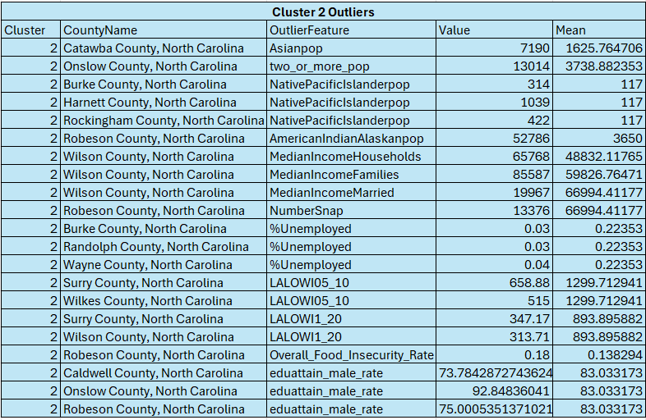

***Figure 3.2:*** *Cluster 2 Outliers*

Robeson County, a notable outlier in cluster 2, has a food insecurity rate of 18%—significantly higher than the cluster average of 13.8%—surpassing Rutherford County by two percentage points. Noteworthy disparities include its educational attainment rate, 8% below the cluster average, and its SNAP recipients totaling 13,376—more than double the cluster's average. Moreover, Robeson County's Indigenous population stands at 52,000, the highest in the state and ten times more than any other county. It also has the highest poverty rate within the dataset at 28.2% and one of the lowest educational attainment rates. A USDA study reveals that only 25.6% of the population in Native American tribal reservations live within one mile of a supermarket, compared to 13% less in Robeson County relative to cluster 2. The county benefits from a network of food pantries that provide food, nutrition counseling, and referrals, with varying hours and eligibility to ensure broad access (Food Pantries, n.d.).  
 Despite these efforts, food insecurity remains a significant challenge in Robeson County, with a rate of 18.0% as of 2019, higher than the North Carolina average of 11.8%. This indicates a substantial need for effective strategies and the expansion of current initiatives to combat food insecurity ​more effectively. While analyzing the counties of North Carolina for effective legislation that combats FI, Wake County's "Moving Beyond Hunger" plan was found to provide detailed strategies that address systemic FI. The plan includes specific policy suggestions to support local food systems. Wake County also focuses on strengthening partnerships among government agencies, non-profits, local businesses, and community members, which is a central aspect of the strategy.  
 These collaborations aim to maximize resources and expertise in addressing food insecurity (Capital Area Food Network, n.d.). Additionally, the plan employs specific metrics to assess its effectiveness, such as tracking improvements in local food production, the amount of food recovered, and the degree of community involvement in food security initiatives. The metrics include the meal gap, which assesses the discrepancy between the food needs of at-risk families and the county's ability to meet those needs through household resources or food assistance programs (Capital Area Food Network, n.d.). These assistance programs use community participation to measure the level of community engagement with the food assistance plan. The program keeps track of the number of residents participating in educational programs about food or volunteering to help improve the program through engagement. Another program called County-Based Food Supply focuses on enhancing local food production and diverting food waste to food rescue programs (Capital Area Food Network, n.d.). The goal is to increase the availability of local, nutritious food.  
 Similarly to Wake County, Mecklenburg County has a balanced demographic split, as seen in Figure 2.4. Like Wake County, Mecklenburg has initiatives in place to combat FI. A program called the Mobile Market provides senior citizens with groceries and fresh produce at 12 locations within the county with a direct phone number available. The program is offered at no cost to those ages 55+. In addition to the high number of SNAP recipients within Mecklenburg County, many food pantries are publicly listed online. A program that helps those in need find a food pantry is called the Food Help Line, which is an online listing of pantries and resources in Charlotte (Mecklenburg County Public Health, n.d.). Another program that Mecklenburg County provides is the Nourish Up program, which provides groceries to Mecklenburg County residents through an extensive network of food pantries, grocery home delivery, and M, and Meals on Wheels (Mecklenburg County Public Health, n.d.). A publicly available hotline is available for each of these programs. As such, many programs must be made available to counties suffering heavily from FI.  
**Conclusion**  
 This study highlights the urgent need for more robust data and nuanced analysis to address food insecurity (FI) effectively. Through the use of k-means clustering and PCA, our analysis revealed distinct demographic, socio-economic, and spatial patterns across four clusters in North Carolina, identifying key factors contributing to FI. For example, Union county features the lowest FI rates by taking advantage of its landscape composition of 46% farmland to establish a teaching community garden. This allows the county to make greater use of its land while maximizing potential to feed and educate its population. On the opposite end, Robeson county with a FI rate of 18.0% indicates a substantial need for effective food assistance programs. Robeson county can look to Mecklenburg and Wake county as examples of food assistance programs that work. The transparency and accessibility of programs in Mecklenburg and Wake county, such as the Nourish Up or Moving Beyond Hunger program have shown that both counties are decreasing their FI rates annually.  
 The limited dataset, restricted to a single year and not covering all counties, particularly pre-COVID-19, significantly hampers the ability to extend our findings to the current environment where FI dynamics have likely evolved. This lack of comprehensive and current data underlines a critical gap in our understanding and our capacity to formulate and implement effective interventions.  
 To advance this important work, we recommend enhancing data collection efforts to include a broader range of years and all counties, integrating post-2020 data to reflect the changing landscape of FI. Such improvements in data availability would enable more precise and timely analysis, facilitating the development of targeted interventions tailored to the unique needs of different communities. By addressing these gaps, future research can better inform policies and practices designed to combat FI, ultimately leading to more resilient food systems and healthier communities across North Carolina.

**References**

Allard, S., & Ruggles, P. (2017). The spatial context of food shopping: Understanding how local food retailer access and pricing affect household behavior. *Journal of Public Policy*, 15(3), 289-307.

Braveman, P. A., Cubbin, C., Egerter, S., Williams, D. R., & Pamuk, E. (2010). Socioeconomic Disparities in Health in the United States: What the Patterns Tell Us. *American Journal of Public Health (1971)*, *100*(S1), S186–S196. <https://doi.org/10.2105/AJPH.2009.166082>

Bowen, S., Elliott, S., & Hardison‐Moody, A. (2021). The structural roots of food insecurity: How racism is

a fundamental cause of food insecurity. *Sociology Compass*, *15*(7). <https://doi.org/10.1111/soc4.12846>

Buys, D. R., & Rennekamp, R. (2020). Cooperative Extension as a Force for Healthy, Rural Communities: Historical Perspectives and Future Directions. *American Journal of Public Health (1971)*, *110*(9), 1300–1303. <https://doi.org/10.2105/AJPH.2020.305767>

Capital Area Food Network. (n.d.). Food security plan. Retrieved from<https://www.capitalareafoodnetwork.org/foodplan>

Chapman, C. (2023, September 29). *Increasing Food Access Blog*. ncIMPACT Initiative. <https://ncimpact.sog.unc.edu/2023/06/increasing-food-access-blog/>

Coleman-Jensen, A., Rabbitt, M. P., Gregory, C. A., & Singh, A. (2021). *Household Food Security in the United States in 2020* (1477th ed.). https://doi.org/10.22004/ag.econ.327186

Corbera-Hincapie, M. A., Kurland, K. S., Hincapie, M. R., Fabio, A., Weiner, D. J., Kim, S. C., & Kazmerski, T. M. (2021). Geospatial Analysis of Food Deserts and Their Impact on Health Outcomes in Children with Cystic Fibrosis. *Nutrients*, *13*(11), 3996-. <https://doi.org/10.3390/nu13113996>

Feeding America. (2017). *Map the Meal Gap 2017*. Retrieved from<https://www.feedingamerica.org/sites/default/files/2019-05/2017-map-the-meal-gap-full.pdf>

Food Pantries. (n.d.). Find food assistance in Robeson County, NC: A comprehensive directory of food pantries. Retrieved from [Food Pantries](https://www.foodpantries.org/co/nc-robeson)

Gundersen, C., A. Dewey, E. Engelhard, M. Strayer & L. Lapinski. Map the Meal Gap 2020: A Report on County and Congressional District Food Insecurity and County Food Cost in the United States in 2018. Feeding America, 2020. [Data set obtained upon request] <https://www.feedingamerica.org/research/map-the-meal-gap/by-county>

Gundersen, C., A. Dewey, E. Engelhard, M. Strayer & L. Lapinski. Map the Meal Gap 2023: A Report on County and Congressional District Food Insecurity and County Food Cost in the United States in 2019-2021. Feeding America, 2023. [Data set obtained upon request] <https://www.feedingamerica.org/research/map-the-meal-gap/by-county>

Hartline-Grafton, H., & Hassink, S. G. (2021). Food Insecurity and Health: Practices and Policies to Address Food Insecurity among Children. *Academic pediatrics*, *21*(2), 205–210. <https://doi.org/10.1016/j.acap.2020.07.006>

Jernigan, V. B. B., Huyser, K. R., Valdes, J., & Simonds, V. W. (2017). Food Insecurity Among American Indians and Alaska Natives: A National Profile Using the Current Population Survey-Food Security Supplement. *Journal of Hunger & Environmental Nutrition*, *12*(1), 1–10. <https://doi.org/10.1080/19320248.2016.1227750>

Mecklenburg County Public Health. (n.d.). Food security. Public Health. Retrieved April 22, 2024, from<https://health.mecknc.gov/population-health/chronic-disease-policy-and-prevention/food-security>

Mutisya, M., Ngware, M. W., Kabiru, C. W., & Kandala, N. (2016). The effect of education on household food security in two informal urban settlements in Kenya: A longitudinal analysis. *Food Security*, *8*(4), 743–756. <https://doi.org/10.1007/s12571-016-0589-3>

Myers, A. M., & Painter, M. A. (2017). Food insecurity in the United States of America: An examination of race/ethnicity and nativity. *Food Security*, *9*(6), 1419–1432. <https://doi.org/10.1007/s12571-017-0733-8>

NC County Health Data - NCIOM. (2021, February 9). NCIOM. <https://nciom.org/nc-health-data/map/>

North Carolina Department of Health and Human Services. (2023). NCDHHS State Action Plan for Nutrition Security 2023-2024. Retrieved from<https://www.ncdhhs.gov/ncdhhs-state-action-plan-nutrition-security-2023-2024/open>

Sigalo, N., St Jean, B., & Frias-Martinez, V. (2022). Using Social Media to Predict Food Deserts in the United States: Infodemiology Study of Tweets. *JMIR Public Health and Surveillance*, *8*(7), e34285–e34285. <https://doi.org/10.2196/34285>

Smith, B. (2024, January 22). Food security in North Carolina. Institute for Emerging Issues.<https://iei.ncsu.edu/2024/01/22/food-security-in-north-carolina/>

Tanoh, V., & Hashemi-Beni, L. (2023). Spatial Analysis of Socioeconomic Factors Contributing to Food Desert in North Carolina. *Sustainability (Basel, Switzerland)*, *15*(10), 7848-. <https://doi.org/10.3390/su15107848>

U.S. Department of Agriculture. (2023). Food and Nutrition Security. (n.d.). <https://www.usda.gov/nutrition-security>

U.S. Department of Agriculture, Economic Research Service. (2023). Definitions of Food Security. <https://www.ers.usda.gov/topics/food-nutrition-assistance/food-security-in-the-u-s/definitions-of-food-security/>

U.S. Department of Agriculture, Economic Research Service. (2023). *Key statistics & graphics*. USDA Economic Research Service.<https://www.ers.usda.gov/topics/food-nutrition-assistance/food-security-in-the-u-s/key-statistics-graphics/>

Walker, R. E., Keane, C. R., & Burke, J. G. (2010). Disparities and access to healthy food in the United States: A review of food deserts literature. *Health & Place*, *16*(5), 876–884. <https://doi.org/10.1016/j.healthplace.2010.04.013>